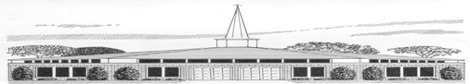
Elementary Activity Afternoons
Registration Form for Youth Activities
Today’s Date: ____________________________ (this form is valid for one year only)
Child’s Name: ___________________________________________________________ |  |  |  | Age: _________________
Address: _______________________________________________________________ |  |  |  | Birthdate: ____________
City: _______________________________________ | Zip: ______________
School: ______________________________________________________________ |  |  |  | Grade: _______________
Mother/Guardian Name: ___________________________________ |  |  | Cell Phone: _________________
Adress (if different): _________________________________________ |  |  | Work Phone: ________________
City: ____________________________________ | Zip: _______ | Email: _________________________
Father/Guardian Name: ____________________________________ |  |  | Cell Phone: _________________
Adress (if different): _________________________________________ |  |  | Work Phone: ________________
City: ____________________________________ | Zip: _______ | Email: _________________________
Emergency Contact: ______________________________________________________________________
Cell Phone: ______________________________________________ |  |  | Relationship: ________________
Elementary School Siblings: ______________________________________________________________

The Annual Medical Release Form MUST also be submitted.

